A NOVEL STEP-UP MULTIINPUT DC–DC CONVERTER FOR HYBRID ELECTRIC VEHICLES APPLICATION
ABSTRACT
In this paper, a multiinput dc–dc converter is proposed and studied for hybrid electric vehicles. Compared to conventional works, the output gain is enhanced. Fuel cell (FC), photovoltaic panel, and energy storage system are the input sources for the proposed converter. The FC is considered as the main power supply, and roof-top PV is employed to charge the battery, increase the efficiency, and reduce fuel economy. The converter has the capability of providing the demanded power by load in absence of one or two resources. Moreover, the power management strategy is described and applied in a control method. A prototype of the converter is also implemented and tested to verify the analysis.

BLOCK DIAGRAM FOR PROPOSED SYSTEM
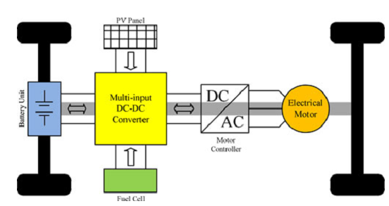
Fig. 1. General structure of the multipowered HEV.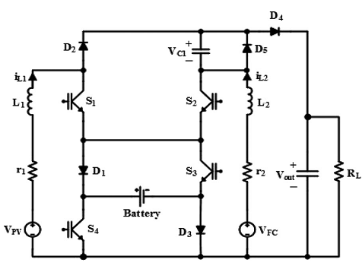
Fig. 2. Three-input dc–dc boost converter.
DESIGNG SOFTWARE AND TOOLS:
MAT LAB /SIMULATION Software and simu power systems tools are used. Mainly control system tools, power electronics and electrical elements tools are used.

